Heirloom shelling beans are beans that have not been manipulated, hybridized or genetically modified. Dry beans are a great source of protein and have been used as a food staple for thousands of years. They are a healthy, tasty addition to soups or salads and make great gifts!

The stories of our beans...

Calypso: Also known as Yin Yang. Originally from the Caribbean, and is at least 400 years old. One of the best for baking and soups. Round black and white seeds with contrasting eye.
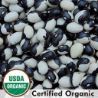

Painted Pony: American and Mexican origin. Excellent for soups and retain their markings when cooked.
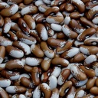

Lina Sisco’s Bird Egg: Family heirloom brought to Missouri by covered wagon in the 1880s by Lina’s grandmother.
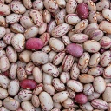

Black Valentine: Introduced in 1897 by Peter Henderson & Company.
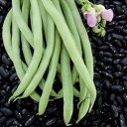

Ireland Creek Annie: English heirloom grown since the 1930s on Ireland Creek Farm in British Columbia. Makes its own thick sauce when stewed.
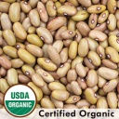

Jacob’s Cattle: Originally cultivated by the Passamaquoddy Native Americans in Maine in the 17th century. Standard for baked beans in the Northeast.
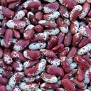

Arikara Yellow: Seeds were originally obtained from the Arikara tribe of North Dakota. Excellent for use as a baking bean.
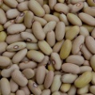

Hidatsa Red: Originally grown by the Hidatsa tribe in the Missouri River Valley of North Dakota.
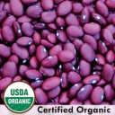

Kenearly Yellow Eye: Developed in Kentville, Nova Scotia. One of the best early baking beans, traditionally used in Maine and Nova Scotia.
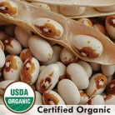

Henderson Bush (Lima): Introduced in 1889 by Peter Henderson Company of New York. A dwarf lima that produces small, creamy white limas.
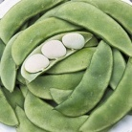

Tiger’s Eye: Produces beautiful gold and maroon beans that originated in Argentina and Peru. The dried beans are prized for their creamy texture and skins that dissolve with cooking.
